ROCIS How to Guide for Agency Users of the Privacy Module

November 4, 2022

Regulatory Information Service Center (RISC)

Table of Contents
1. Logging In/Out 3
2. Your User Profile 9
3. User/Contact Search 10
4. User Recertification and Reauthorization 11
5. Agency Inbox and the Navigation Toolbar 16
6. Creating a SORN Package 19
7. Uploading SORN Documents 26
8. Creating an MA Package 30
9. Uploading MA Documents 34
10. Submitting a SORN/MA Request 37
11. The Review Process and Open/Close for Amendment 39
12. The Conclusion Process 42
13. Adding a Federal Register Citation to a Concluded Request 43
Appendix A: Required Documents 45
Appendix B: SORN Agency Roles 49

1. Logging In/Out

Point your browser to the ROCIS website (www.rocis.gov) to login to the system.
MAX.gov provides user identity authentication services to ROCIS including ID/password validation, 2-factor authentication and PIV/CAC card access. All ROCIS users will need a MAX.gov account to access ROCIS. If you do not have a MAX.gov account, please register at the MAX.gov website (https://portal.max.gov/portal/home).
Click the Login button on the next screen to verify your identity with MAX.gov.

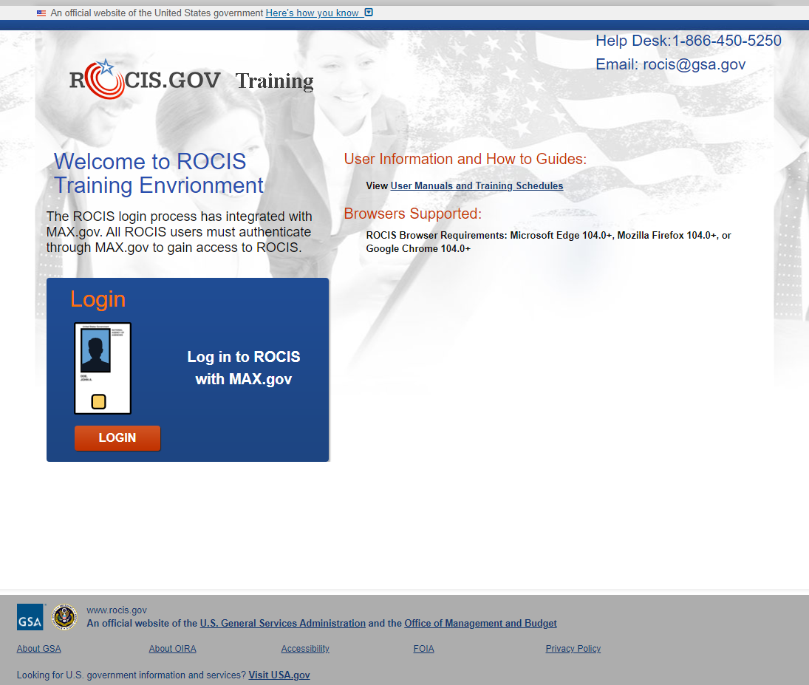
Figure 1.1: Login Screen
Logging in to MAX.gov with your PIV/CAC card satisfies the ROCIS multi-factor authentication requirement. If you login to MAX.gov with your user ID and password, you will be required to provide a second authentication factor using an authenticator app on your mobile device.
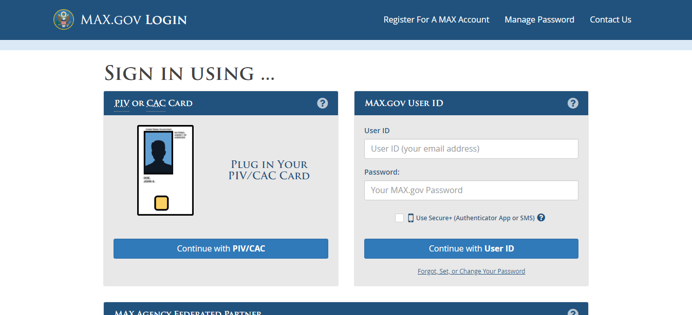
Figure 1.2: MAX.gov Login Screen
After successfully logging in to MAX.gov, you will be redirected to ROCIS.
Click the arrow for the ‘Privacy’ module to continue.
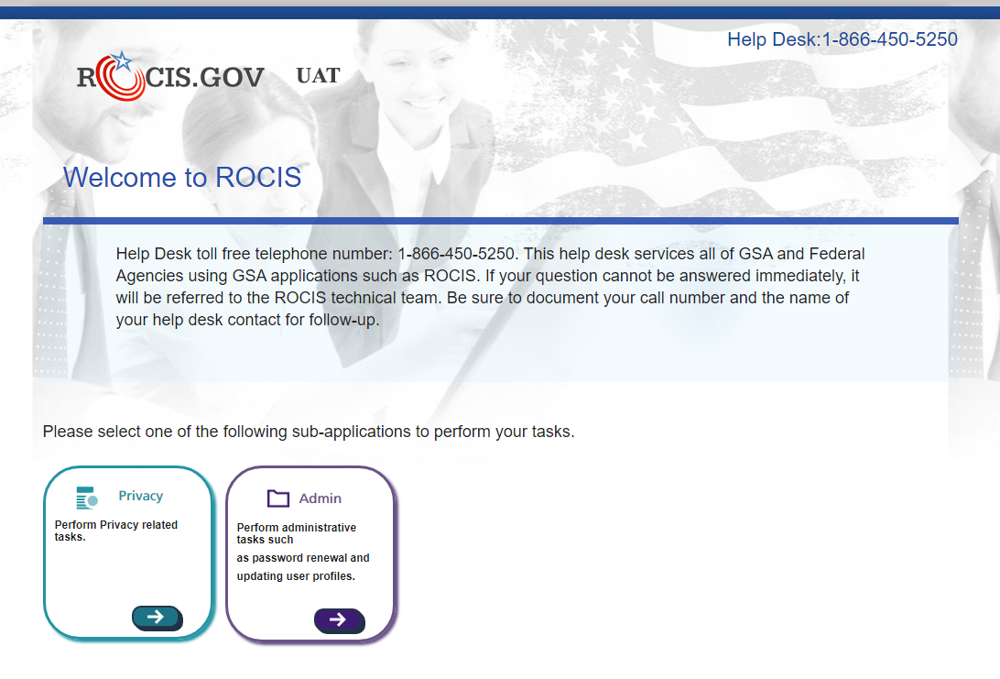
Figure 1.3: ROCIS Landing Page
Click the Logout link at the top, right corner of any ROCIS page to logout of ROCIS.
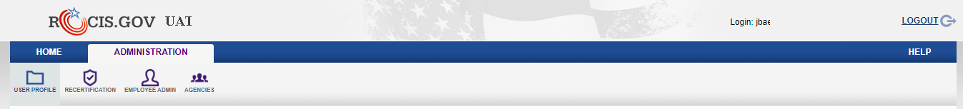
Figure 1.4: Logout Link
Logging out of ROCIS does not automatically log you out of MAX.gov. You MAX.gov session may still be active which means that you can log back in to ROCIS without having to re-verify your identify in MAX.gov. To protect your privacy, close all browser windows when you are finished, especially if you are using a public computer. By taking these steps, you ensure the security and privacy of your agency's data in ROCIS.
On the next screen, click the MAX Logout button to log out of MAX.gov. This will require you to log back in to MAX.gov before the next time you access ROCIS. Click the ROCIS Login button to log back in to ROCIS.
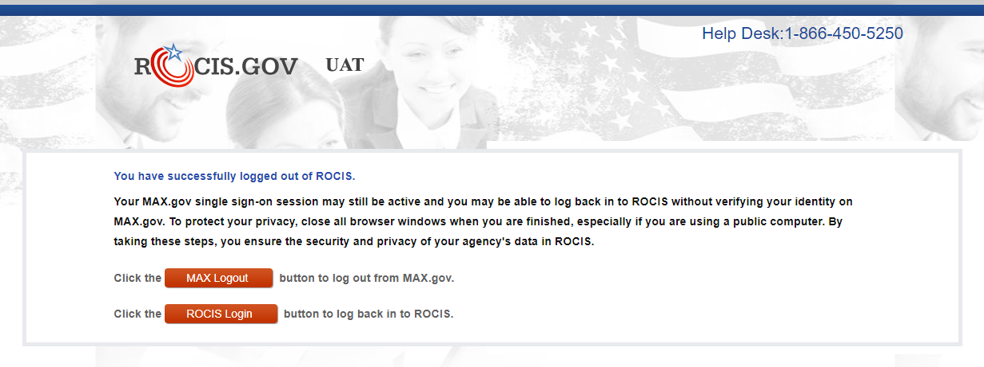
Figure 1.5: Logout Screen

User Manuals and Training Schedules
ROCIS user manuals and training schedules are available online. Click the User Manuals and Training Schedules link on the Login screen to open the resources page.
Figure 1.6: Login Screen with User Resources Link
The user can download the latest version of the agency guidelines for submitting their Unified Agenda for review. There are also agency user manuals for each of the ROCIS modules available in MS Word and PDF formats. A link to OIRA’s online guide to the Paperwork Reduction Act (https://pra.digital.gov/) is available, as well.
Training schedules and registration information is also available. There is no cost for ROCIS training. There are 2 training documents on the user resources screen:
- Unified Agenda & Reg Plan –
  - Twice per year (weeks before Unified Agenda data call is expected)
  - Takes users through the steps to request a RIN when a new regulation is under development.
- EO 12866, PRA and Privacy –
  - E.O. 12866 –
    - Quarterly (October, January, April, July)
    - Covers the steps necessary to create and submit an EO 12866 Review package.
  - PRA –
    - Monthly
    - Covers the steps necessary to create and submit an Information Collection Request (ICR).
  - Privacy –
    - Quarterly (December, March, June, September)
    - Covers the steps necessary to create and submit a System of Records Notice (SORN) and a matching notice (MA).
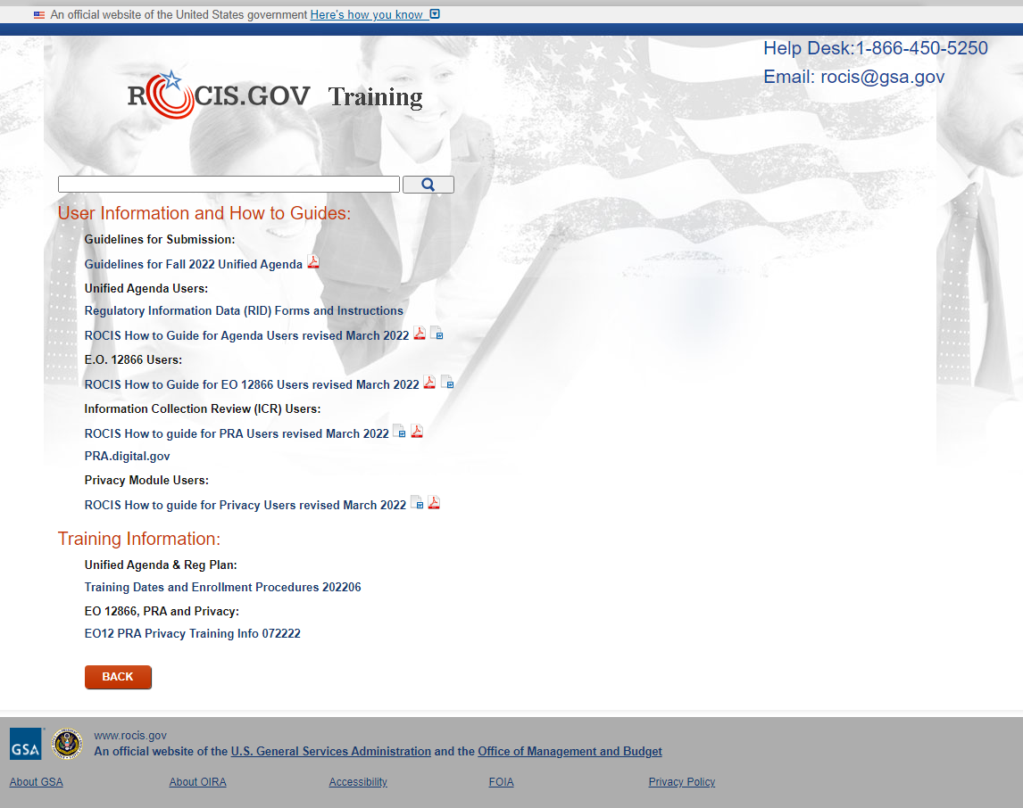
Figure 1.7: User Resources Screen
After logging in, click the User Guides link in the Navigation toolbar to open the User Resources screen.
Figure 1.8: Navigation Toolbar

2. Your User Profile

Take a moment to review your user profile. Click the Administration tab. Then click the User Profile icon in the Administration toolbar. The User Profile page provides you a place to view and update your user information.

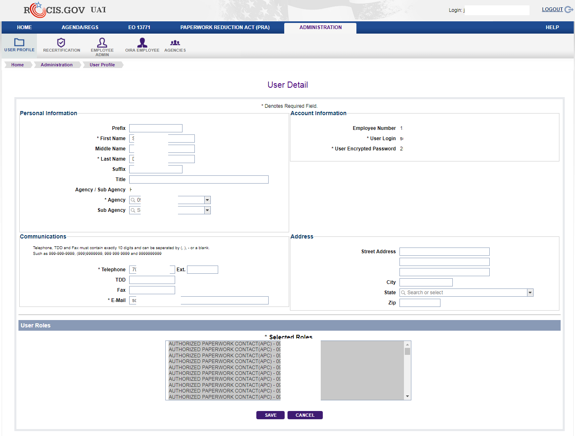

Figure 2.1: User Profile Icon and User Detail Screen

Please verify and make appropriate changes to any information, paying particular attention to your telephone number and email. Save your information. The ‘Save’ button is located at the bottom of the screen.

Remember to the User Profile to modify your personal information, such as your phone number or e-mail address, whenever changes occur.

Your profile will also display the role(s) that have been assigned to your user id. A list of the agency Privacy roles can be found in Appendix B.
To leave the User Profile page, scroll to the bottom and click ‘Save’ (if you changed anything) or ‘Cancel’. This will take you back to the ROCIS Employee Administration screen.

3. User/Contact Search

The purpose of the Employee Administration screen is to allow ROCIS users to find other ROCIS users via the search capability. For instance, if you would like to send another ROCIS user an e-mail, you are able to search by the user’s agency, role and/or name.

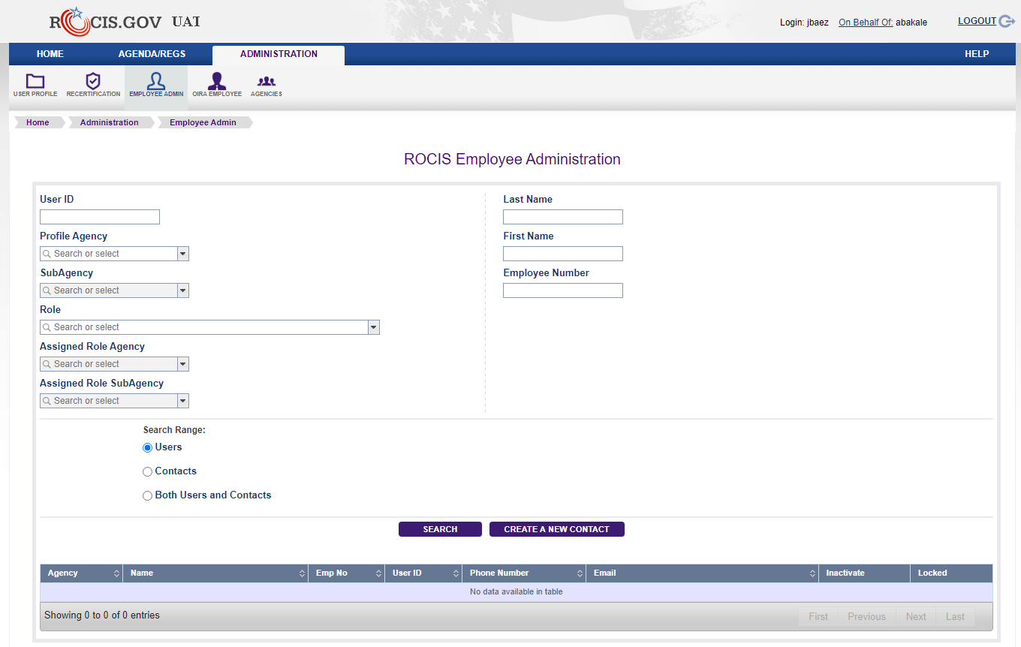

Figure 3.1: Employee Administration Screen

If you are the agency’s SORN Administrative Contact, it is a good idea to periodically check the authorized users for your agency. Simply choose the desired role (SSPO, SAC, SP, SPO and/or SPU) and your Assigned Role Agency and click the Search button. If there are people who have left your agency and still have active accounts, please contact the Help Desk so that the accounts can be inactivated and locked.

When you have satisfied your ROCIS administrative functions, click on the Privacy tab to return to the Created Request List Inbox for Agency users.

4. User Recertification and Reauthorization

User Recertification
Any user acquiring a ROCIS production account must sign a security agreement provided by RISC. The ROCIS system requires that users recertify the terms of the security agreement every year.

Two weeks before your security agreement anniversary date, ROCIS will begin to remind you that you will need to recertify. The Recertification icon can be found under the Administration tab.

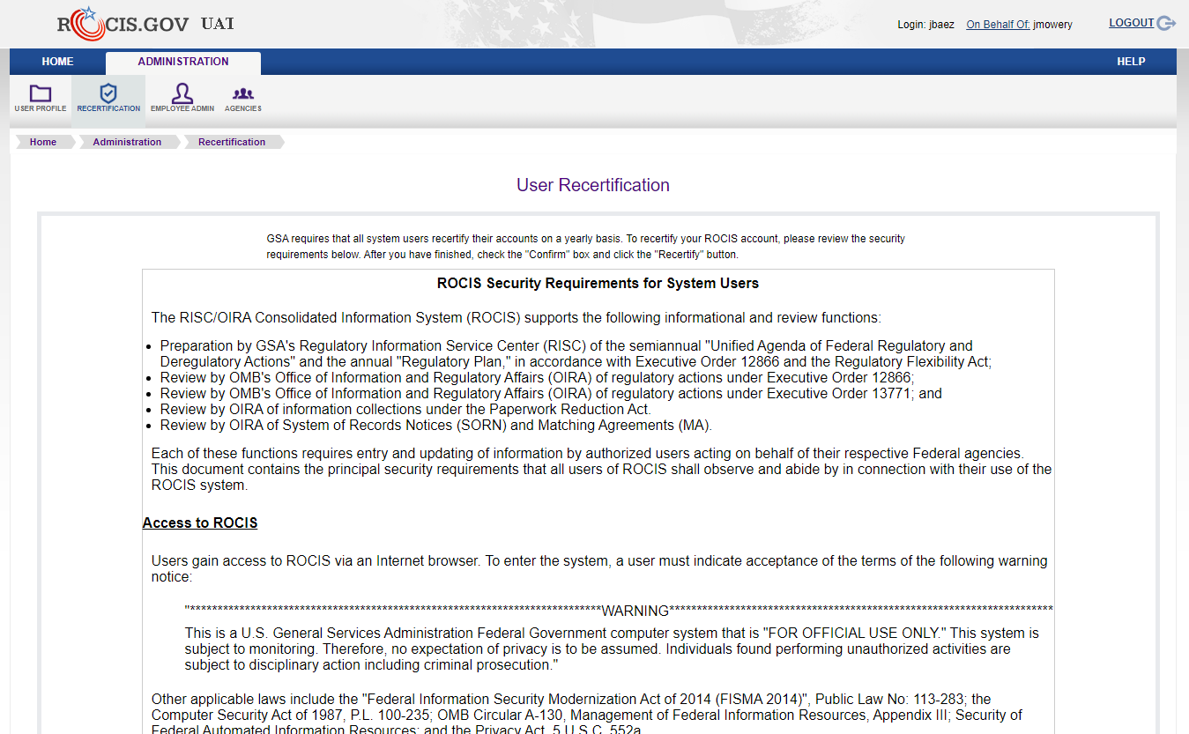

Figure 4.1: Recertification Icon in Administration Toolbar

The latest version of the ROCIS Security Agreement is displayed on the Recertification screen. After reviewing the page, check the ‘Confirm’ box and click the Recertify button. After successfully logging in to MAX.gov, your recertification anniversary date will be updated in ROCIS.

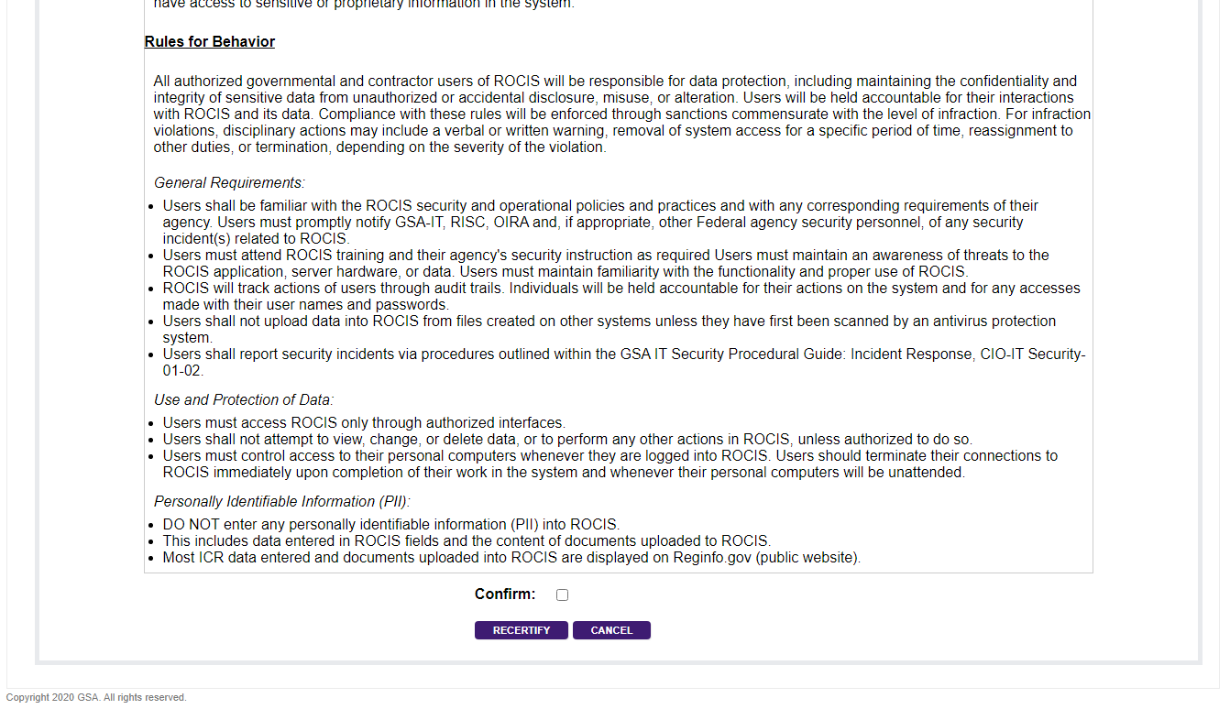

Figure 4.2: User Recertification Screen (Bottom)

If you do not recertify through the process above BEFORE your anniversary date, ROCIS will automatically send you to the ‘User Recertification’ screen the next time you log in. If you do not recertify, you will be logged out. This process will be repeated until you complete the Recertification process.

User Reauthorization
Any user acquiring a ROCIS production account must be authorized by the agency. The ROCIS system requires agencies to reauthorize user access every year.

Starting 10 days before your annual reauthorization deadline, you will receive daily warnings and email notifications. If your account is not reauthorized before the deadline, your ROCIS access will be suspended (i.e. user cannot log in). Agency authorizer(s) contact information will be provided.

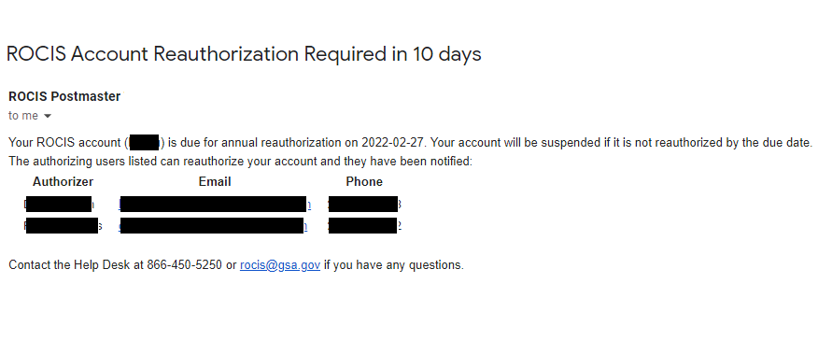

Figure 4.3: User Reauthorization Required Email

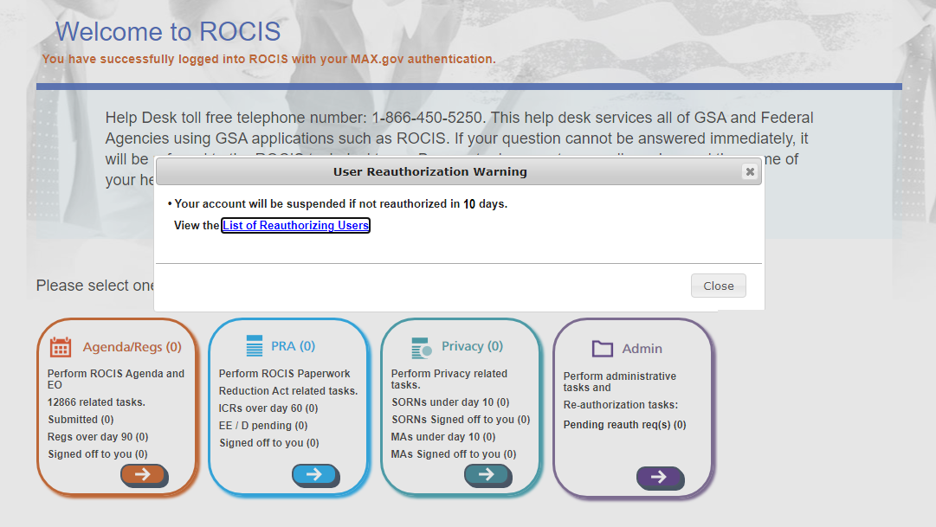

Figure 4.4: User Reauthorization Required Warning

Agency authorizers must review ROCIS user access, at least annually, to validate that the individual still has a business need for their access. Authorizers will receive daily warnings and email notifications when there are users that they can reauthorize whose access will be suspended in 10 days or less.

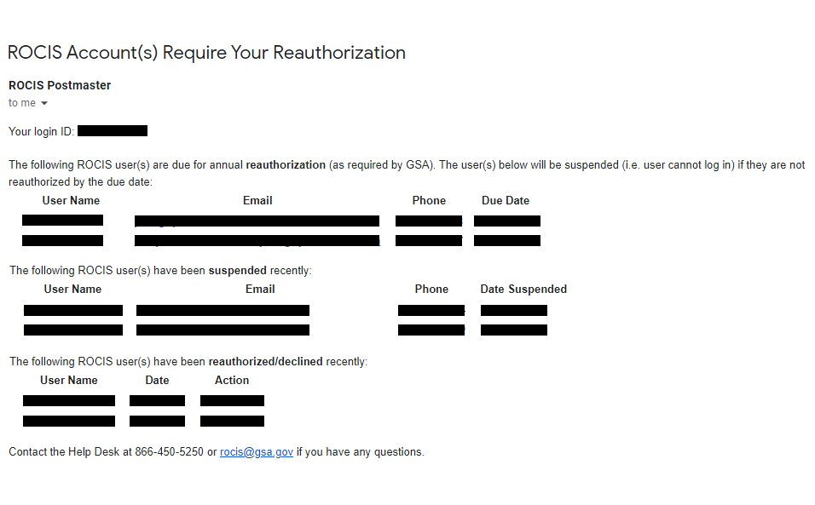

Figure 4.5: User Reauthorization Required Email (Authorizer)

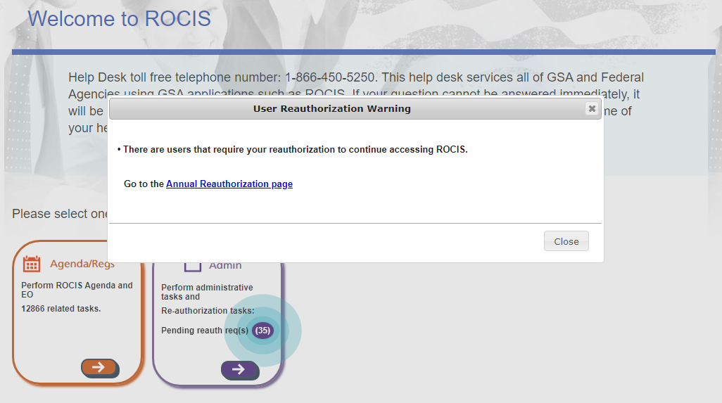

Figure 4.6: User Reauthorization Required Warning (Authorizer)

Agency authorizers have the ability to reauthorize or decline user access in ROCIS. Click on the Annual Reauth icon under Administration to reauthorize users (Authorizers only).

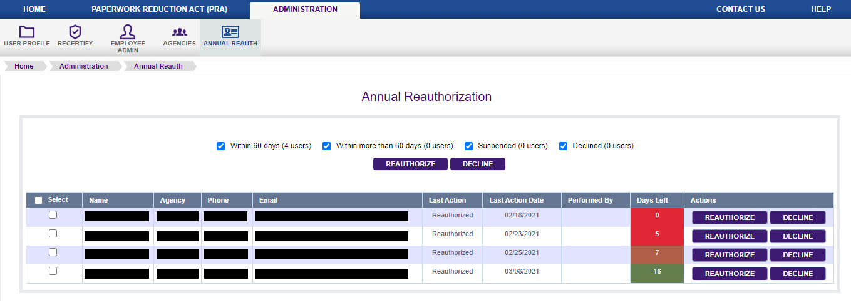

Figure 4.7: User Reauthorization Screen (1 at a time)

Figure 4.8: User Reauthorization Screen (1+ at a time)

5. Agency Inbox and the Navigation Toolbar

At the top of the screen is a tab for each of the ROCIS modules you have access to. Each module has its own set of tabs/icons that work like drop-down menus. Wave your mouse cursor over a tab or icon to view menu options. If no options appear, click the tab/icon to navigate to that location. These rows of tabs/icons are referred to as the Navigation Toolbar.

ROCIS provides all users with an Inbox menu for tracking the progress Privacy requests. The menu includes different lists, each of which is discussed below. Wave your mouse cursor over the Inbox icon in the navigation toolbar to access the various sections:

- Created Request List – Includes requests that have been created in ROCIS, but have not been submitted to OIRA for review. These requests may also be deleted from ROCIS (not reversible, cannot be recovered).

- Submitted Request List – Includes requests that have been submitted to OIRA for review. It also includes requests that have been opened for amendment by OIRA.

- Concluded Request List – Includes requests for which OIRA has completed their review. Displays last 30 days of conclusions, by default.

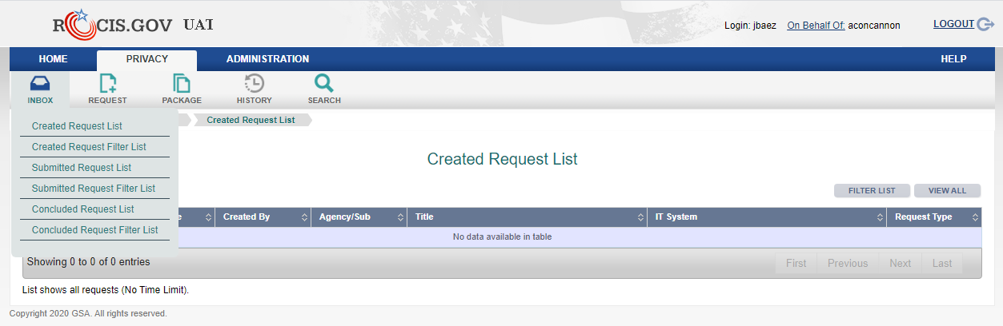

Figure 5.1: Created Request List with Inbox Menu

You can sort any list by any of the columns. The first time a user clicks on the column heading, the column data is sorted. Click it again to reverse the sort order.

Each of the lists in your Inbox has a Filter List page. Click the Filter List button on any list to view the fields that you can filter that list on. For example, you can use the Concluded EO Package Filter page to expand the Concluded EO List and display requests concluded more than 30 days ago.

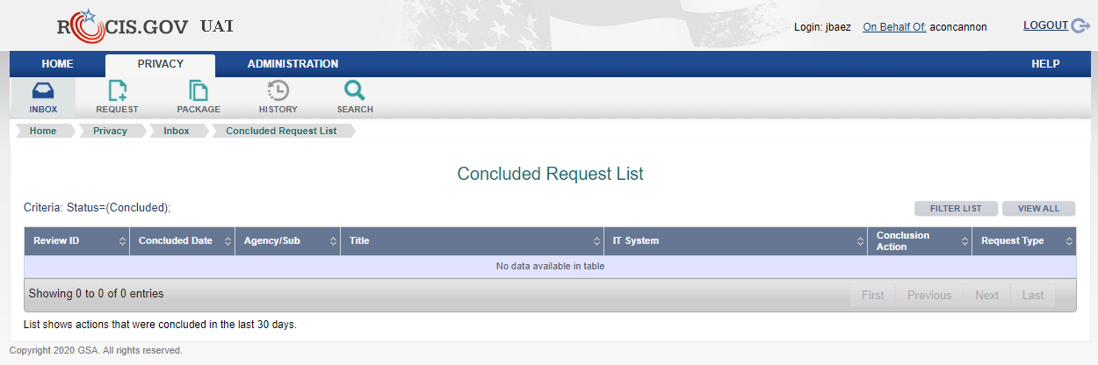

Figure 5.2: Concluded Request List with Filter List Button

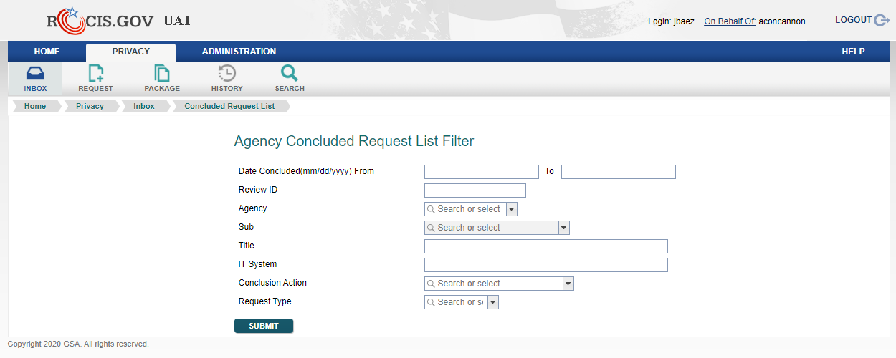

Figure 5.3: Concluded Request List Filter Screen

Each list is display in pages with 10 requests per page, by default. Click the View All button on any list to view all of the requests in that list on one page.

Figure 5.4: Concluded Request List with View All Button

6. Creating a SORN Package

When you are ready to create a SORN Package, choose ‘Request’ from the navigation toolbar. You will see a drop down list with two items, ‘System of Records Notice (SORN)’ and ‘Matching Agreements (MA)”. Select the SORN option by highlighting it with your mouse and left-clicking once.
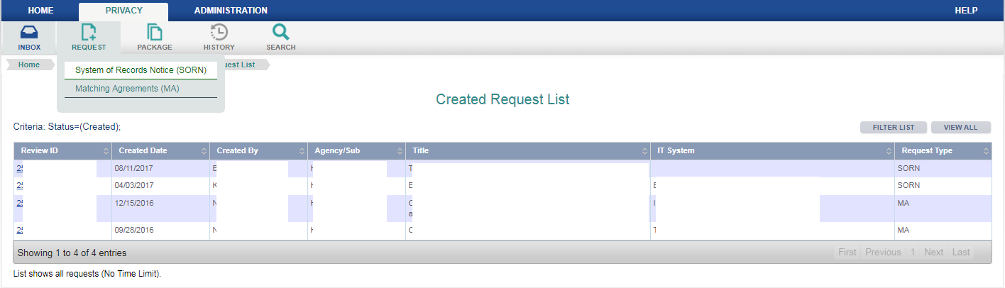

Figure 6.1: SORN Package Option in Request Menu

You will be presented with a new screen, showing two ways to create a SORN package.
The first option is used when creating a new SORN package with no SORN related Review ID.

The second option is used when creating a new SORN package related to a previously reviewed SORN that has already been reviewed by OIRA through the ROCIS system and published in the Federal Register. The OIRA conclusion action must be either ‘Reviewed with Change’ or ‘Reviewed without Change’—it cannot be ‘Improperly Submitted’ or ‘Withdrawn’. When choosing this option, a new SORN request will be created for the same agency/subagency as the related SORN, and many data items from the related SORN request will be copied into the new request.

To discuss all of the data items for a SORN request, the first option will be selected for this example.

After choosing to create a new SORN package, the screen below will be displayed. Users must select an agency, a subagency if appropriate, and enter a title and abstract.

Whenever ROCIS supplies a drop down list of values from which to choose, there is a small arrow at the end of the input box. For agency and subagency, ROCIS will display the values that the user is authorized to access.

Matching sets of upward and downward pointing arrows indicate that the input box allows scrolling. So, for example, if the abstract entered is greater than can be displayed in the box, the user can scroll up or down through the text.

Notice the three buttons underneath the Abstract text area. A user can check spelling of text items using the ‘Check Spelling’ button, save the data entered to date and create a new SORN request with the ‘Create’ button, or erase unsaved data with the ‘Cancel’ button.

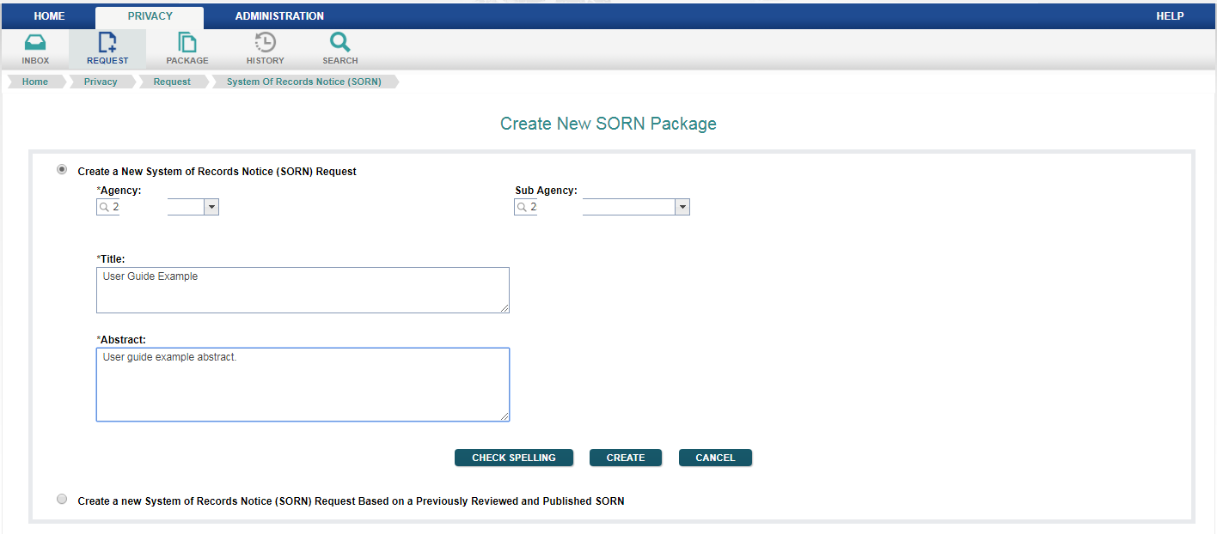

Figure 6.2: Create New SORN Package Screen

After the request has been successfully created, the user is transferred to the ‘Edit SORN Request’ screen. The agency or subagency number and acronym are displayed, as well as the unique SORN Review ID automatically assigned by ROCIS to this particular request. These items may not be changed.

Also at the top of the screen is a link to the ‘Manage Documents’ portion of the SORN process. That will be discussed under the ‘Upload Documents’ topic in the manual.

All data items marked with an asterisk are required before a request can be submitted to OIRA. If the item does not have an asterisk, it is optional.

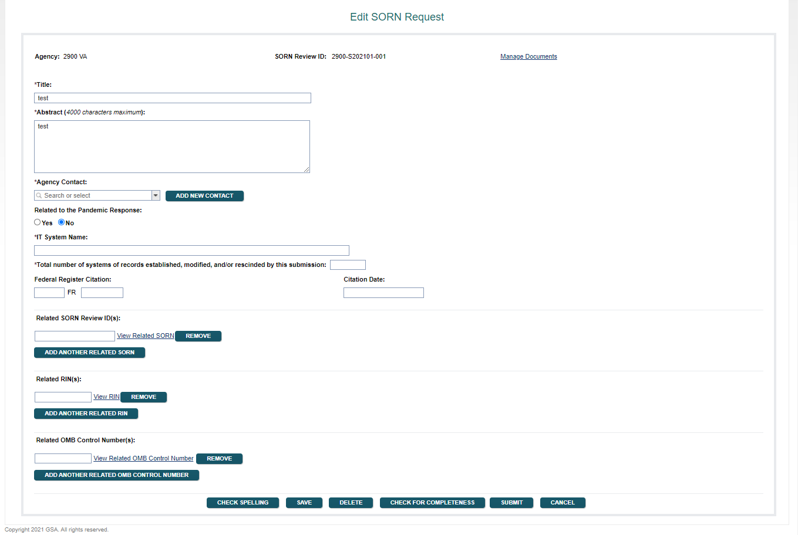

Figure 6.3: Edit SORN Request Screen

Title and Abstract are required data items. They may be changed on this screen.

Agency Contact is required: This should be the individual that the OIRA desk officer can contact with any questions about the SORN request. If the user clicks on the arrow at the end of the input box, ROCIS will display a list of others from the organization that have been identified as contacts in ROCIS previously. If the name of the appropriate individual appears in the list, simply highlight the name, and ROCIS will select that person. If the name of the individual is not in the list, the user can create a new contact by selecting the ‘Add New Contact’ button.

The ‘Add Contact’ process begins with an administrative task ‘ROCIS Contact Administration’. Enter some portion of the name that you want to locate, and then click on the ‘Search’ button.

The search results will be displayed at the bottom of the screen. The persons located are not limited to Privacy contacts. They represent all types of ROCIS contacts, including those for the agenda module, the EO Reg Review module and the PRA module.

If you see the name that you want to add as a contact, click on the name in the search result portion of the page.

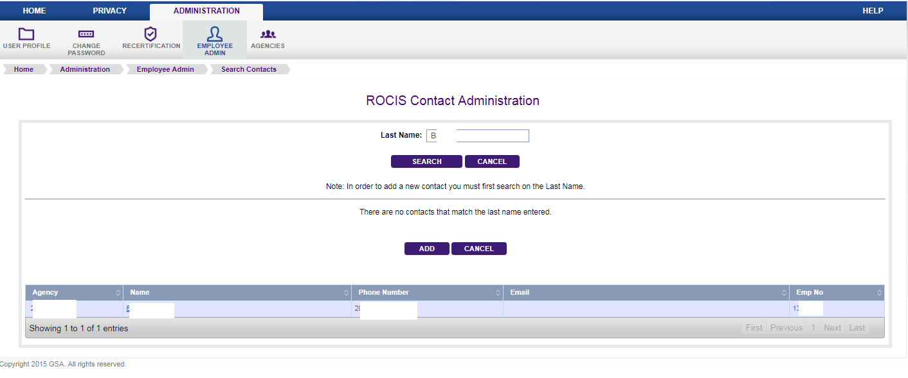

Figure 6.4: Contact Administration Screen

In this example, Julio Baez was selected. Julio is in ROCIS as a contact for the agenda module. That can be determined by noting the check next to ‘RIN Contact’. The check and active status are not highlighted because your role does not allow you to change agenda contacts. However, you can make Julio a contact for the Privacy module by clicking on the box next to ‘Privacy Contact’.

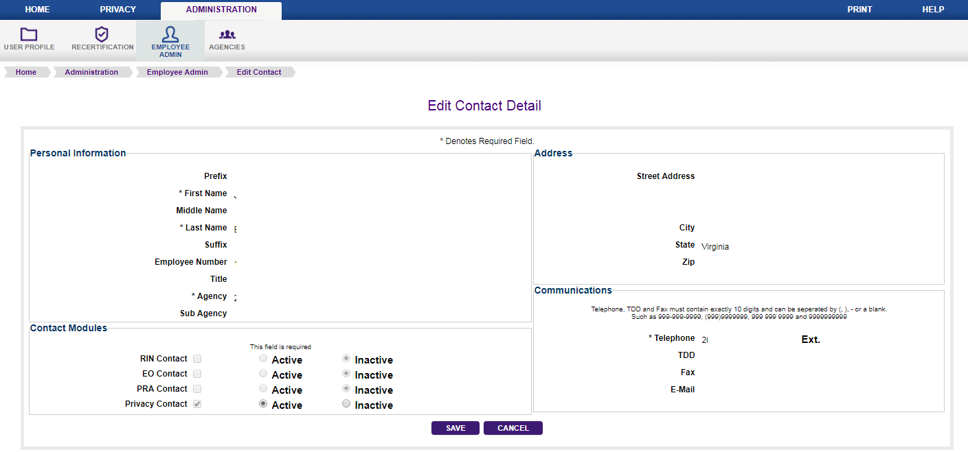

Figure 6.5: Edit Contact Detail Screen

Scroll down to the bottom of the screen and click on the ‘Save’ button to effect the change. After the information is saved, you will be returned to the Edit SORN Request screen.

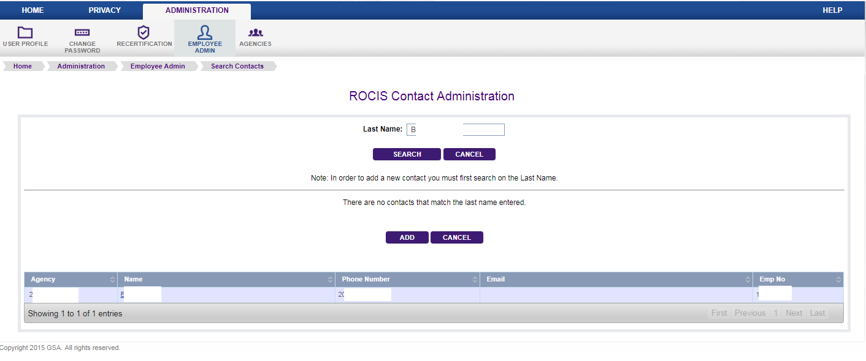

Figure 6.6: Contact Administration Screen (continued)

The ‘New Contact Detail’ screen captures information about the new contact. Any data item with an asterisk in front of the tag is a required field. Although ‘Email’ is not required, it is highly desirable that it be entered.

The agency item has a drop down list from which the agency or subagency for the contact can be selected. This is an important decision if you are associated with a cabinet agency (except VA) or EPA. These have an agency level code which ends with ‘00’, and a number of subagencies. If the contact is associated with the agency code, he will appear in the drop down list for any subagencies that are part of that agency. If he is associated with a subagency, he will only appear in the drop down list for that subagency.

In this example, the user has access to both ‘0500’, the agency code for Department of Commerce, and the subagency ‘0506’, the USDA Office of Communications, so both numbers on listed in the drop down list. If the user selects ‘0500’ as Charles’ (the new contact), agency, Charles Williams will appear as a Privacy contact for any subagency within Commerce. If he is associated with 0607, she will only be a contact for Census. If someone were to create a Privacy package for subagency 0605, Charles would not appear in the list. If Charles was supposed to be a contact for 0605, another contact record would have to be added showing her agency as ‘0605’. If Charles should be a contact for all subagencies within Commerce, but you don’t have access to ‘0600’, please contact someone who does and ask that user to set up Nancy’s contact record. You can use the Employee Admin search described above to find someone with access to ‘0600’.

Click ‘Create User’ at the bottom of the screen. The new contact will be saved, and you will be returned to the ‘Edit SORN Request’ screen. All of the contacts that you have selected will be displayed. You can manipulate the order of the contacts by changing the number to the right of the contact information. You can also remove a contact by clicking on ‘remove’.

Related to the Pandemic Response: This item is required. Choose “Yes” if the request is related to the [COVID-19] Pandemic Response, otherwise choose “No”.

IT System Name: This item is required. Please enter the name of the system to which this SORN applies.

Total number of systems of records established, modified, and/or rescinded by this submission: This item is required.

The remaining data items on this screen are optional.

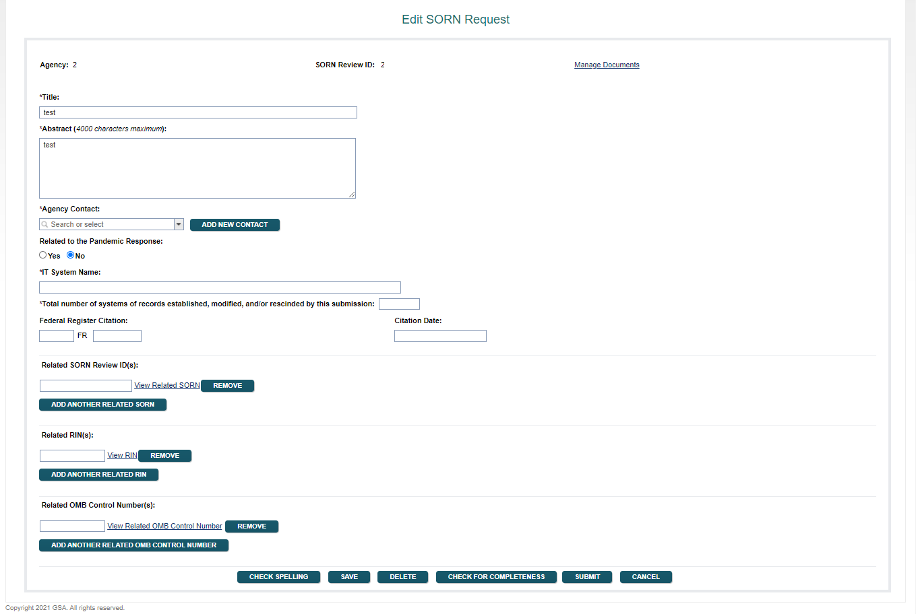

Figure 6.7: Edit SORN Request Screen

Federal Register Citation and Citation date indicate when the SORN in question was published in the Federal Register. If the request is submitted to OIRA at the same time that the notice is sent to the Federal Register, this data will not be available until after the review is concluded. A valid citation contains a volume number, a page number, and the publication date in the format MM/DD/YYYY. ROCIS does not accept partial FR citation information. All three data items must be entered at the same time. Given a valid citation date, the associated FR volume would be YYYY – 1935. ROCIS will not accept a citation date earlier than 1950.

Related SORN Review ID: Optional field which contains a SORN Review ID for a request that was previously reviewed by OIRA and has a publication date indicating that it has appeared in the Federal Register. A SORN request can only be related to another SORN review if they are for the same agency or subagency.

Related RIN(s): Optional field to indicate that this request is related to a rulemaking that has been entered into the Unified Agenda and assigned a Regulatory Identification Number (RIN)
A Related RIN can be any valid RIN, regardless of Agency.

Related OMB Control Number(s): Optional field to indicate that this request is related to a submission under the Paperwork Reduction Act that has been assigned a valid OMB Control Number. A Related OMB Control Number can be any valid OMB Control Number, regardless of Agency.

At this point, all of your data should be saved by selecting the ‘Save’ Button. (Data can be saved at any time during the editing process). You will then be ready to add the necessary documents to your request.

Figure 6.8: Edit SORN Request Screen with ‘Save’ Button

7. Uploading SORN Documents

To upload (electronically attach) the required documents, move to the top of the ‘Edit SORN Request’ screen and click on the link to ‘Manage Documents’. Or, mouse over ‘Package’ in your navigation toolbar, mouse over ‘Current Package’ from the drop down list, and then click on ‘Documents’.

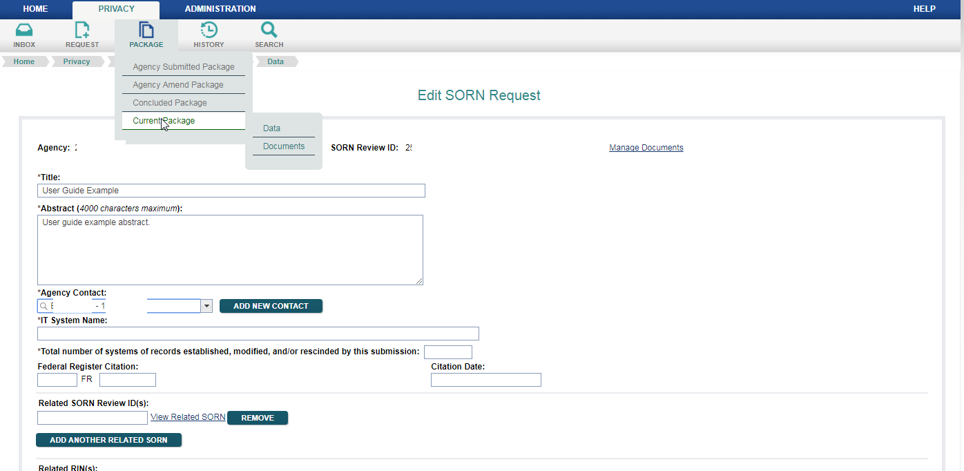

Figure 7.1: Edit SORN Request Screen with Paths to Manage Documents Screen

With either method, the user will be presented with a new screen from which to load documents.

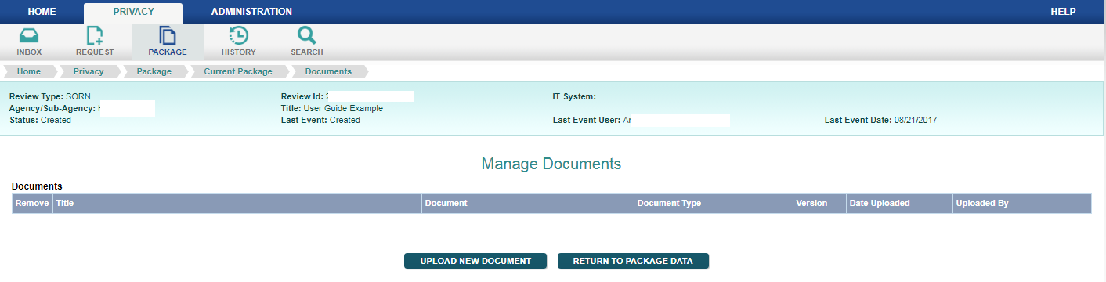

Figure 7.2: Manage Documents Screen

Every SORN request requires a Transmittal Letter, a Narrative Statement and a Federal Register Notice. Details on what each type of document should contain can be found in Appendix A.

To upload a new document, click on the button with that label. A new pop-up window will appear, prompting the user for a title and the corresponding document type. The user will select the document type from the drop down list provided.

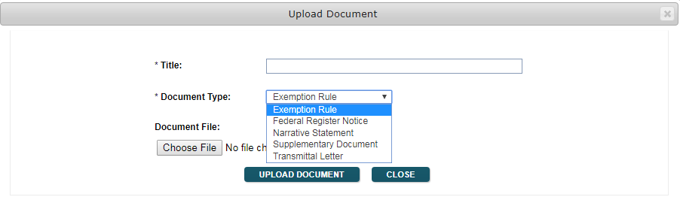

Figure 7.3: Upload Document Pop-up Screen

The third field is for the name of the file that you want to upload. Click the ‘Browse’ button, and ROCIS will allow you to browse files on your local computer to find the right document. Once you have found it, simply click on the file name and it will appear in the window. Next, click the ‘Open’ button, and the path to the document will appear in the ROCIS window. Finally, click the ‘Upload Document’ button, and ROCIS will attach the file electronically to your submission.

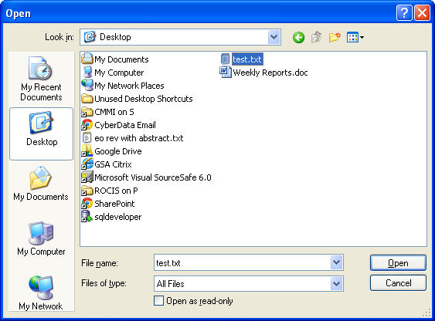

Figure 7.4: ‘Choose File’ Pop-up Screen

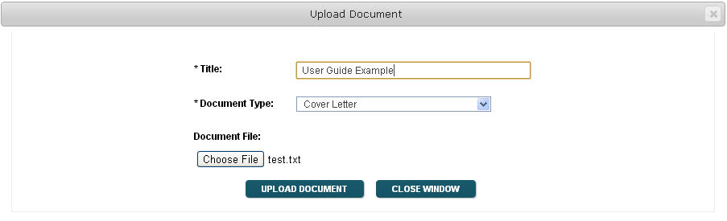

Figure 7.5: Upload Document Pop-up with Path to Chosen Document

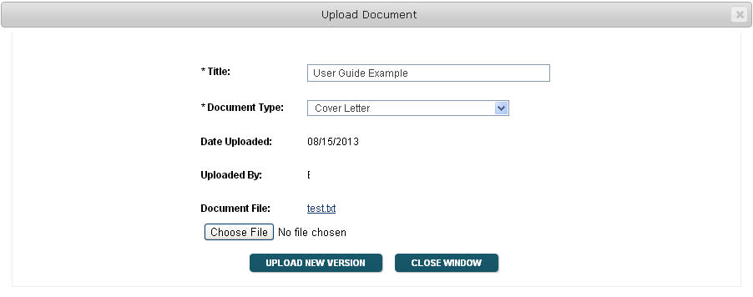

Figure 7.6: Upload Document Pop-Up Screen after Upload

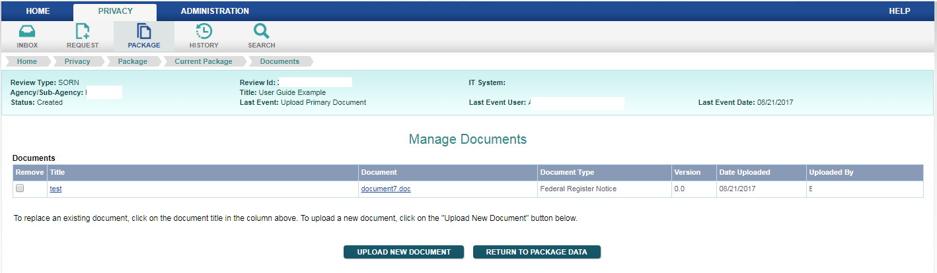

Figure 7.7: Manage Documents Screen with Transmittal Letter Uploaded

There is also now a box under the ‘Remove’ column. Should you want to delete this document, check the box by clicking on it, and then hit ‘Enter’ on your keypad. The document will be deleted from the ROCIS system.

If you find that you want to replace an already uploaded document, click on the document name. This method will allow you to replace the document. You should never have more than one version of each document type, except for Supplementary Documents (multiple are allowed), associated with your SORN request.

After you have uploaded all of your documents, return to the package by using the button provided. You will again be at the ‘Edit SORN Request’ screen.

8. Creating an MA Package

When you are ready to create an MA Package, choose ‘Request’ from the navigation toolbar. You will see a drop down list with two items, ‘System of Records Notice (SORN)’ and ‘Matching Agreements (MA)”. Select the MA option by highlighting it with your mouse and left-clicking once.
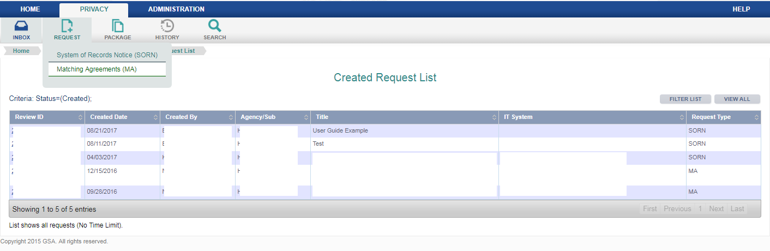

Figure 8.1: MA Package Option in Request Menu

You will be presented with a new screen, showing two ways to create an MA package.
The first option is used when creating a new MA package with no MA related Review ID.

The second option is used when creating a new MA package related to a previously reviewed MA that has already been reviewed by OIRA through the ROCIS system and published in the Federal Register. The OIRA conclusion action must be either ‘Reviewed with Change’ or ‘Reviewed without Change’—it cannot be ‘Improperly Submitted’ or ‘Withdrawn’. When choosing this option, a new MA request will be created for the same agency/subagency as the related MA, and many data items from the related MA request will be copied into the new request.

To discuss all of the data items for an MA request, the first option will be selected for this example.

After choosing to create a new MA package, the screen below will be displayed. Users must select an agency, a subagency if appropriate, and enter a title and abstract.

Whenever ROCIS supplies a drop down list of values from which to choose, there is a small arrow at the end of the input box. For agency and subagency, ROCIS will display the values that the user is authorized to access.

Matching sets of upward and downward pointing arrows indicate that the input box allows scrolling. So, for example, if the abstract entered is greater than can be displayed in the box, the user can scroll up or down through the text.

Notice the three buttons underneath the Abstract text area. A user can check spelling of text items using the ‘Check Spelling’ button, save the data entered to date and create a new MA request with the ‘Create’ button, or erase unsaved data with the ‘Cancel’ button.

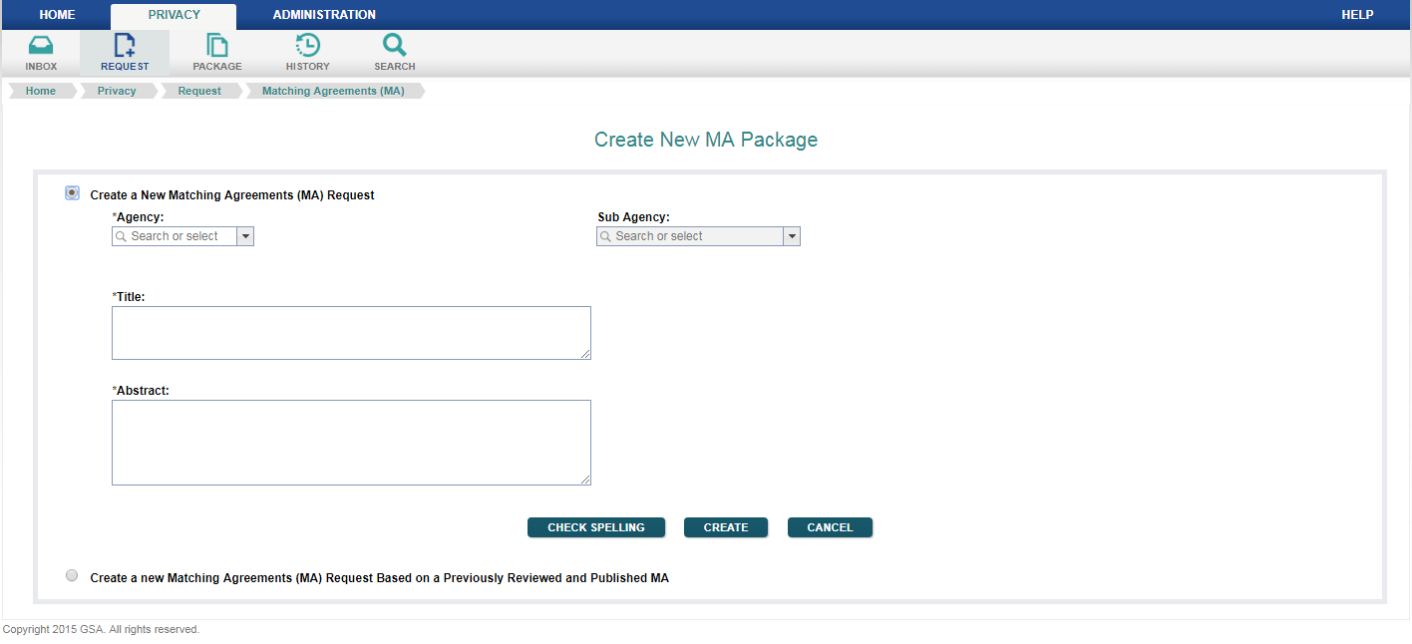

Figure 8.2: Create New MA Package Screen

After the request has been successfully created, the user is transferred to the ‘Edit MA Request’ screen. The agency or subagency number and acronym are displayed, as well as the unique MA Review ID automatically assigned by ROCIS to this particular request. These items may not be changed.

Also at the top of the screen is a link to the ‘Manage Documents’ portion of the MA process. That will be discussed under the ‘Upload Documents’ topic in the manual.

All data items marked with an asterisk are required before a request can be submitted to OIRA. If the item does not have an asterisk, it is optional.

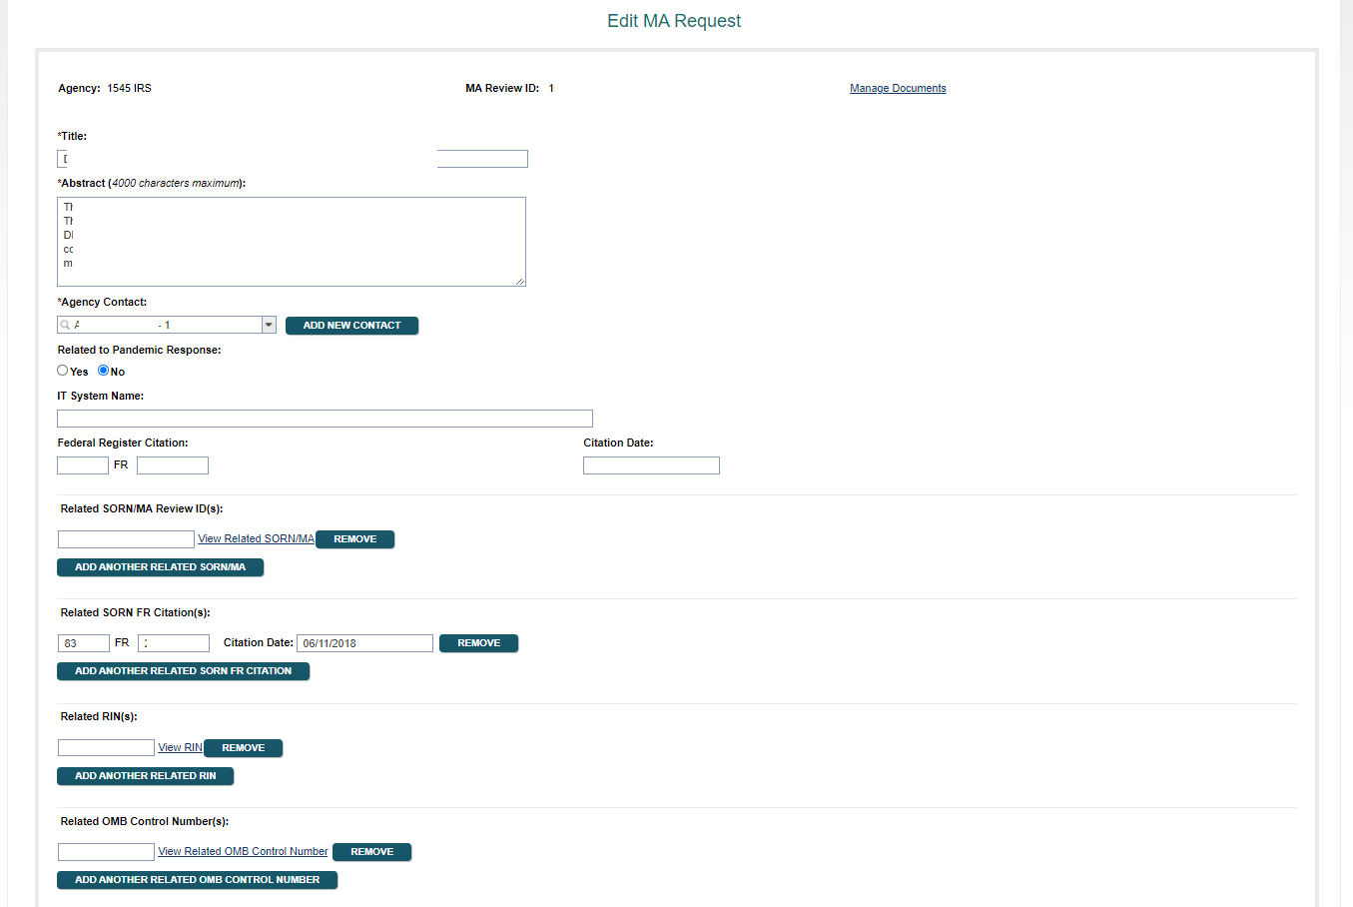

Figure 8.3: Edit MA Request Screen

Title and Abstract are required data items. They may be changed on this screen.

Agency Contact is required: This should be the individual that the OIRA desk officer can contact with any questions about the MA request. If the user clicks on the arrow at the end of the input box, ROCIS will display a list of others from the organization that have been identified as contacts in ROCIS previously. If the name of the appropriate individual appears in the list, simply highlight the name, and ROCIS will select that person. If the name of the individual is not in the list, the user can create a new contact by selecting the ‘Add New Contact’ button.

See section 6, “HOW TO Create and Edit a SORN Package”, for information on how to manage contacts in ROCIS.

Related SORN/MA Review ID: Conditional field which contains an MA Review ID for a request that was previously reviewed by OIRA and has a publication date indicating that it has appeared in the Federal Register. An MA request can only be related to another MA or SORN review if they are for the same agency or subagency. Related SORN/MA Review ID is required when no Related SORN FR Citation has been entered.

Related SORN FR Citation: Conditional field which contains the FR citation for a SORN that has been published in the Federal Register. A valid citation contains a volume number, a page number, and the publication date in the format MM/DD/YYYY. ROCIS does not accept partial FR citation information. All three data items must be entered at the same time. Given a valid citation date, the associated FR volume would be YYYY – 1935. ROCIS will not accept a citation date earlier than 1950. Related SORN FR Citation is required when no Related SORN/MA Review ID has been entered.

Related to the Pandemic Response: This item is required. Choose “Yes” if the request is related to the [COVID-19] Pandemic Response, otherwise choose “No”.

The remaining data items on this screen are optional.

IT System Name: Please enter the name of the system to which this MA applies.

Federal Register Citation and Citation Date indicate when the MA in question was published in the Federal Register. If the request is submitted to OIRA at the same time that the notice is sent to the Federal Register, this data will not be available until after the review is concluded. A valid citation contains a volume number, a page number, and the publication date in the format MM/DD/YYYY. ROCIS does not accept partial FR citation information. All three data items must be entered at the same time. Given a valid citation date, the associated FR volume would be YYYY – 1935. ROCIS will not accept a citation date earlier than 1950.

Related RIN(s): Optional field to indicate that this request is related to a rulemaking that has been entered into the Unified Agenda and assigned a Regulatory Identification Number (RIN)
A Related RIN can be any valid RIN, regardless of Agency.

Related OMB Control Number(s): Optional field to indicate that this request is related to a submission under the Paperwork Reduction Act that has been assigned a valid OMB Control Number. A Related OMB Control Number can be any valid OMB Control Number, regardless of Agency.

Participating Agency/Subagency(s): Optional field to indicate the federal agencies participating in the MA. One or more agencies can be selected from a drop-down list and added to the MA request.

Non-federal Participant(s): Optional field to indicate the non-federal parties participating in the MA. Enter the names of the non-federal participants in the space provided.

At this point, all of your data should be saved by selecting the ‘Save’ Button. (Data can be saved at any time during the editing process). You will then be ready to add the necessary documents to your request.

9. Uploading MA Documents

To upload (electronically attach) the required documents, move to the top of the ‘Edit MA Request’ screen and click on the link to ‘Manage Documents’. Or, mouse over ‘Package’ in the navigation toolbar, mouse over ‘Current Package’ from the drop down list, and then click on ‘Documents’.

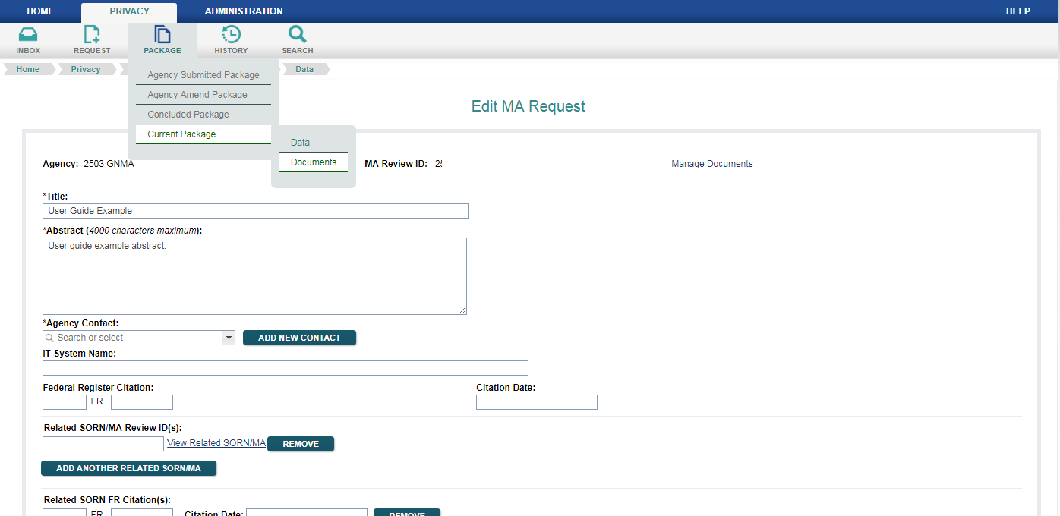

Figure 9.1: Edit MA Request Screen with Paths to Manage Documents Screen

With either method, the user will be presented with a new screen from which to load documents.

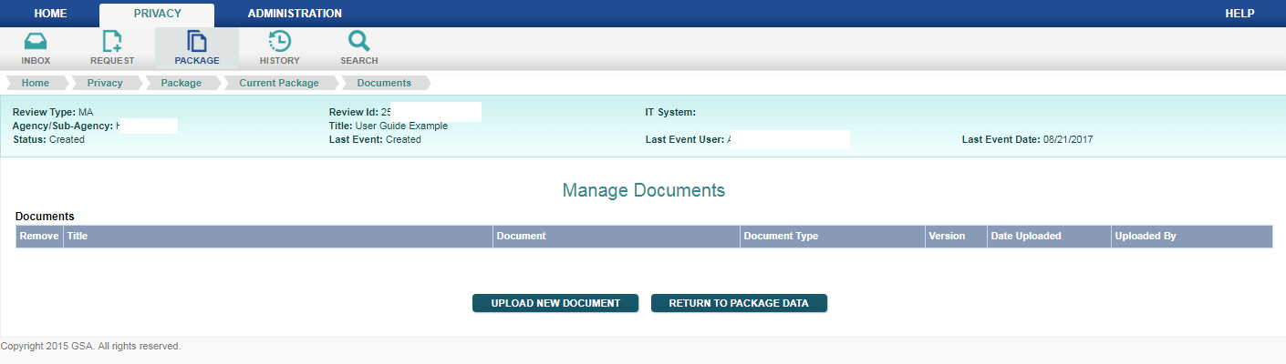

Figure 9.2: Manage Documents Screen

Every MA request requires a Transmittal Letter, a Narrative Statement, at least one Matching Agreement and a Federal Register Notice. Details on what each type of document should contain can be found in Appendix A.

To upload a new document, click on the button with that label. A new pop-up window will appear, prompting the user for a title and the corresponding document type. The user will select the document type from the drop down list provided.

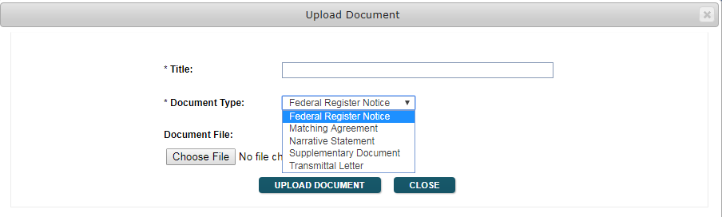

Figure 9.3: Upload Document Pop-up Screen

The third field is for the name of the file that you want to upload. Click the ‘Browse’ button, and ROCIS will allow you to browse files on your local computer to find the right document. Once you have found it, simply click on the file name and it will appear in the window. Next, click the ‘Open’ button, and the path to the document will appear in the ROCIS window. Finally, click the ‘Upload Document’ button, and ROCIS will attach the file electronically to your submission.

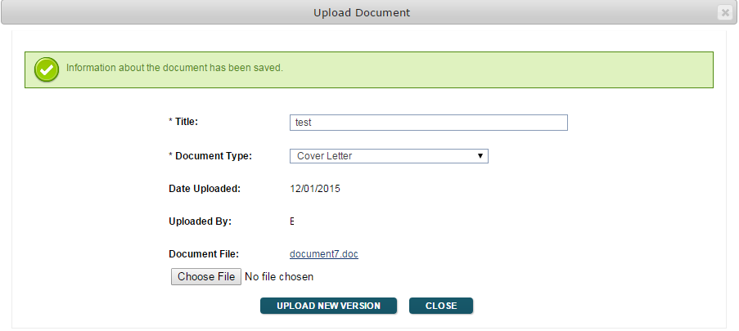

Figure 9.4: Upload Document Pop-up Screen after Upload

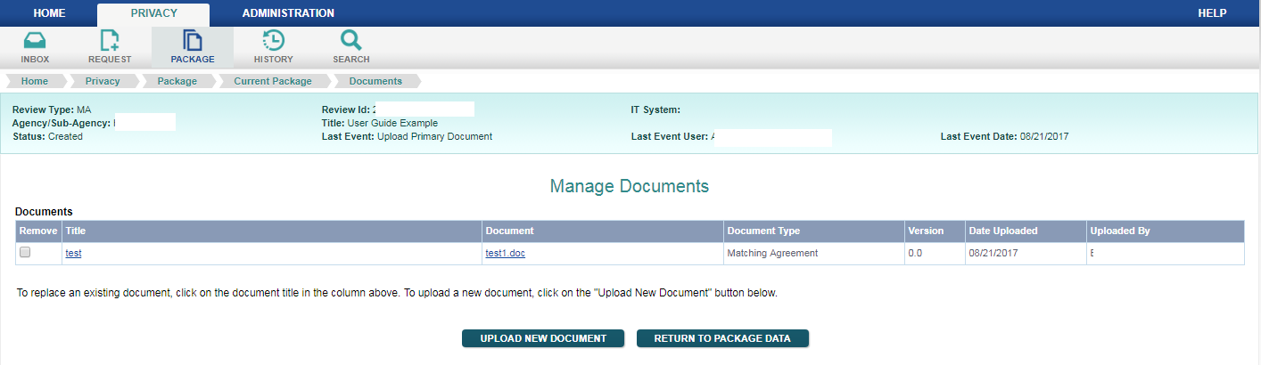

Figure 9.5: Manage Documents Screen with Transmittal Letter Uploaded

There is also now a box under the ‘Remove’ column. Should you want to delete this document, check the box by clicking on it, and then hit ‘Enter’ on your keypad. The document will be deleted from the ROCIS system.

If you find that you want to replace an already uploaded document, click on the document name. This method will allow you to replace the document. You may have more than one Matching Agreement and Supplementary Document associated with your MA request. Only 1 version of the other document types is allowed.

After you have uploaded all of your documents, return to the package by using the button provided. You will again be at the ‘Edit MA Request’ screen.

10. Submitting a SORN/MA Request

After entering all required data and uploading the necessary documents, you may want to perform a ‘Check for Completeness’ by selecting the button with that label at the bottom of the ‘Edit SORN Request’ or ‘Edit MA Request’ screen. ROCIS will do a validation of the data and documents. The result of the validation will be displayed at the top of the screen. ROCIS will either advise you that the request is complete, or notify you to provide information on what is missing.
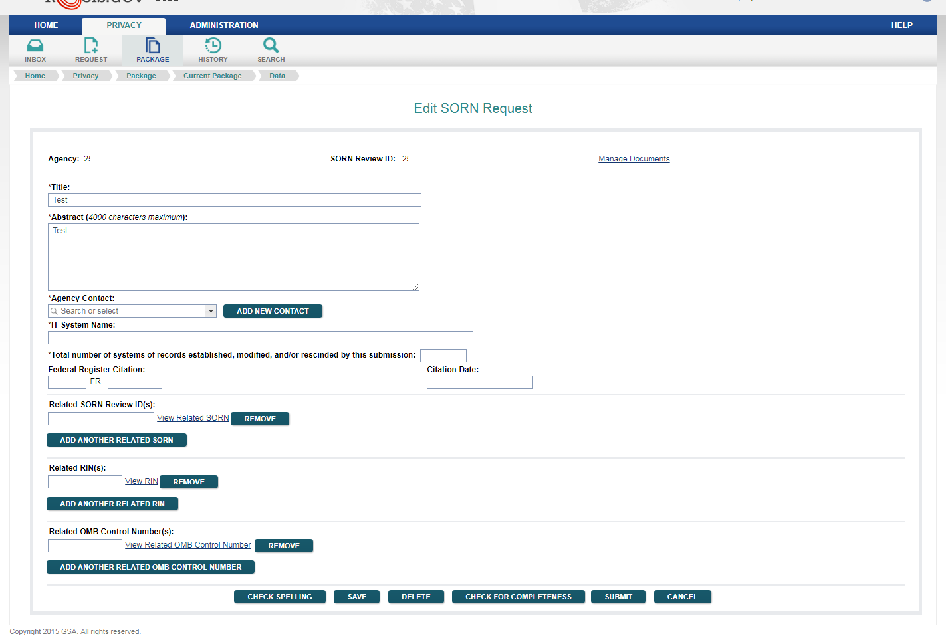

Figure 10.1: Edit SORN Request Screen with Check for Completeness Button

The request is now ready to be submitted. Whether the ‘Submit’ button is available on your screen depends on your level of access to the Privacy module. If you do not have the ‘Submit’ button, save your request and notify an Senior Privacy Officer (SPO) at your organization that the request is ready to be submitted to OIRA. If you do not know who has SPO privileges, refer to the section on Employee Administration to perform a search by agency and role.

If the ‘Submit’ button does appear on your screen, simply select it. ROCIS will respond with a message asking if you want to submit on behalf of the SORN Senior Privacy Officer for your agency. If everything looks fine, click ‘OK’. The request will immediately be submitted to OIRA, and you will be transferred to your ‘Submitted Request List’.

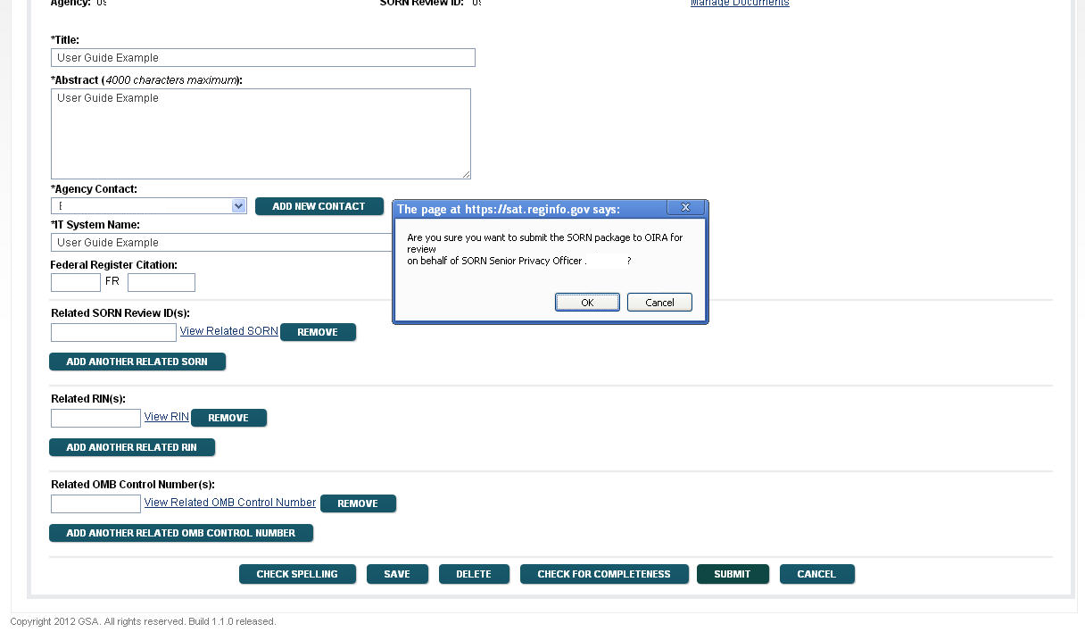

Figure 10.2: Edit SORN Request Screen with Submit Verification Message

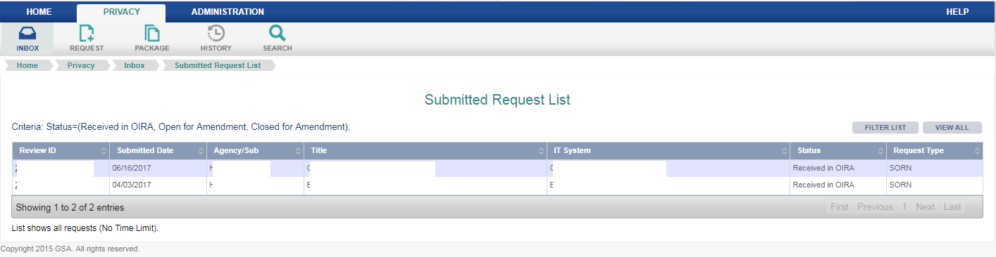

Figure 10.3: Submitted Request List Inbox Screen

11. The Review Process and Open/Close for Amendment

When the SORN/MA request is submitted, the ROCIS system saves the agency submission (request data and documents), and that submission record is never altered. Instead, at the same time, the system makes an exact copy of the submission and provides it to OIRA. While the SORN/MA package is under review, OIRA may request that the agency make changes to the submission. These changes will be made to the OIRA copy of the record. In order for the agency to make changes to the OIRA version of the submission, an OIRA desk officer must open the record for amendment. Such an action on the part of OIRA will show as a change of status in the submitted box for the agency. The status will be changed to ‘Open for Amendment’. Once a request has this status, the agency can operate on the submission by clicking on either the status or the Review ID in the submitted list, and make the changes discussed with OIRA.

You will see the change to ‘Open for Amendment’ in the status column of the request in your ‘Submitted’ box.

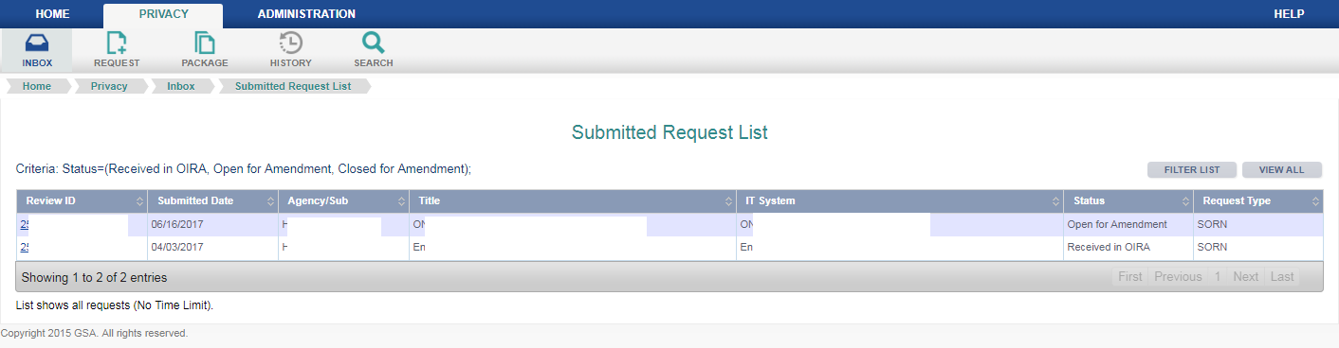

Figure 11.1: Submitted Request List Inbox Screen

To make changes to the package, select it by clicking on the Review ID.

Not every item can be changed when a submission is opened for amendment. Items that cannot be changed will appear in gray. Except for these items, users can make any data changes.

Users may also upload new versions of documents while the package is ‘Open for Amendment’. You should always upload new versions of existing documents, rather than uploading new documents. Uploading new documents will result in duplicates of document types. Your request cannot be resubmitted if it contains, for example, more than one Transmittal Letter with the same version number. To upload a new version, click on the document name. The process to browse your local desktop files will be the same as it was before. When the new document is uploaded, it will show as another version of the same type of document.

When the necessary changes to the review package have been made, an SPO should select the ‘Resubmit’ button at the bottom of the ‘Edit SORN Request’ or ‘Edit MA Request’ screen. This will change the status to ‘Close for Amendment’, thus notifying the OIRA desk officer that the changes are completed. The OIRA desk officer also has the ability to change the status to ‘Close for Amendment’.

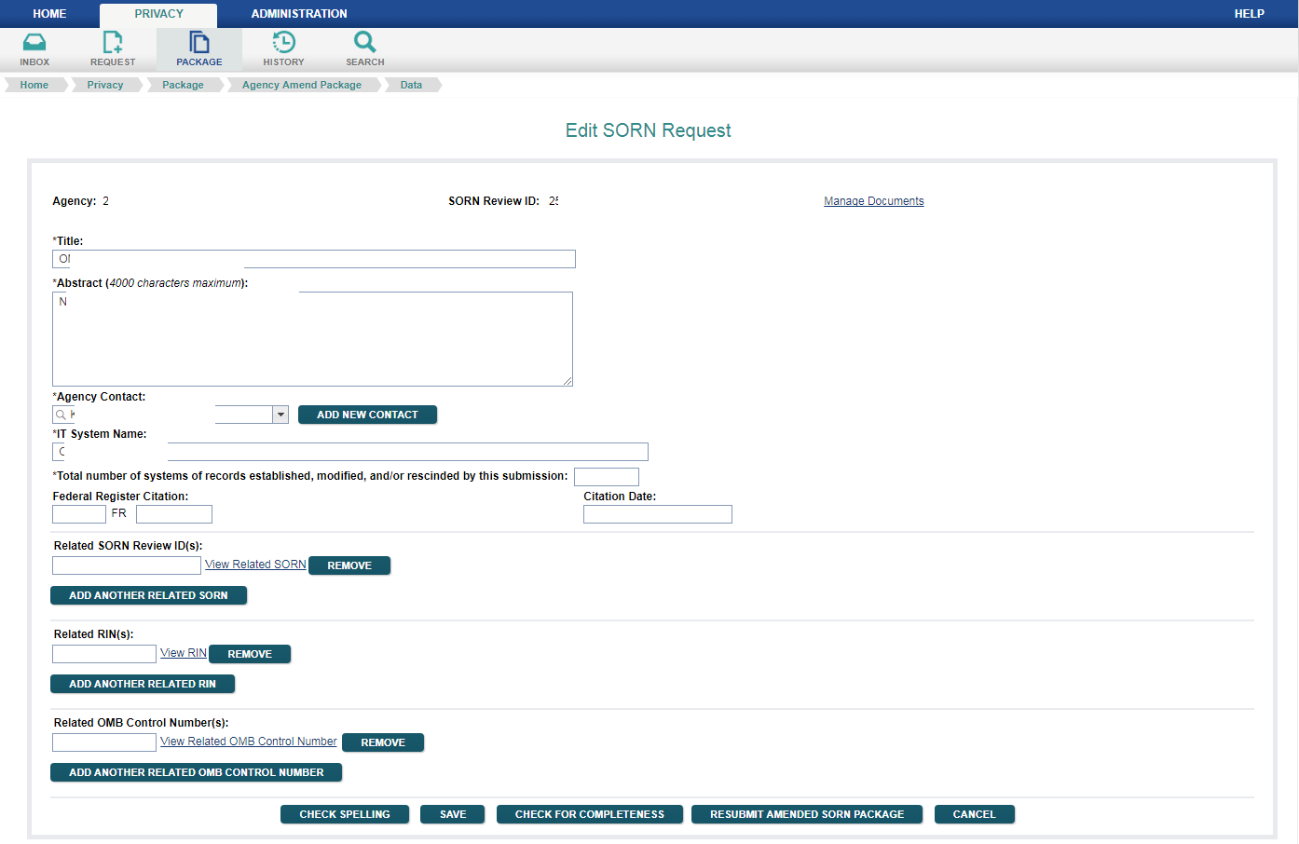

Figure 11.2: Edit SORN Request Screen with Resubmit Button

ROCIS will automatically transfer you back to your ‘Submitted’ list, where you can view the change in status.

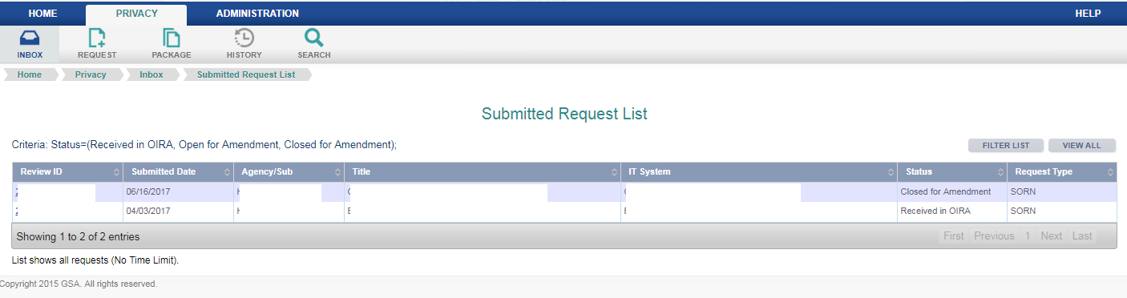

Figure 11.3: Submitted Request List Inbox Screen

Once the status is changed to ‘Closed for Amendment’, the modifications made to the OIRA record will no longer be viewable by the agency. When an agency user views the submission, the user will be looking at the original version of the submission, not the modified copy ‘belonging’ to OIRA. That will be true until the review is concluded by OIRA. Once the review is concluded, the OIRA version of the record will become the default displayed version of the review. However, the agency can always choose to look at the original submission by going to the Package menu and choosing the ‘Agency Submitted Package’ option.

12. The Conclusion Process

When OIRA concludes review of the SORN/MA submission, ROCIS will display the submission in the agency‘s Concluded Inbox for 30 days. The agency can review all the information on the concluded review by clicking on the Review ID.

OIRA can conclude the review with any of a number of actions. These include:
- Reviewed without Change—the request was reviewed by OIRA, and no substantive changes were necessary
- Reviewed with Change—the request was reviewed by OIRA and changes were made by the agency to the submission
- Improperly Submitted—OIRA determined that the request was not appropriate for OIRA review
- Withdrawn—the submitting Agency asked that the request be withdrawn from consideration

OIRA generally has 30 days to review the SORN/MA submission. In ROCIS, every submission is assigned a Due Date (30 calendar days from submission). OIRA can delay a review indefinitely. Reviews are automatically concluded on the Due Date (as “Reviewed without Change”) if OIRA takes no action in ROCIS. Packages that have been opened for amendment are not eligible for auto-conclusion.

Agencies may proceed with publication when the review is concluded as “Reviewed with Change” or “Reviewed without Change”.

13. Adding a Federal Register Citation to a Concluded Request

The SORN/MA will be published in the Federal Register after OIRA review is concluded. It is important that the FR citation be added to the concluded package.

The FR citation may be added to a previously reviewed package by an agency SORN user with a role of SORN Publication Updater (SPU). If there is no user at your agency that has this role, you should have your SORN Administrative Contact call the ROCIS Help Desk to make arrangements to have someone fill this role.

An SPU locates the appropriate package either in the concluded box or via a simple search.
Click on the Review ID, and ROCIS will display the OIRA Conclusion Screen. The data items for publication volume, page number and date will be shown as entry boxes. Enter the publication information, and select the ‘Add FR Publication Data’ button. Be sure that the data is correct, since once the ‘OK’ is selected and the data is entered, it cannot be changed. If incorrect citation data is entered and processed by ROCIS, please call the ROCIS Help Desk at 866-450-5250 to ask for assistance from the ROCIS technical team.

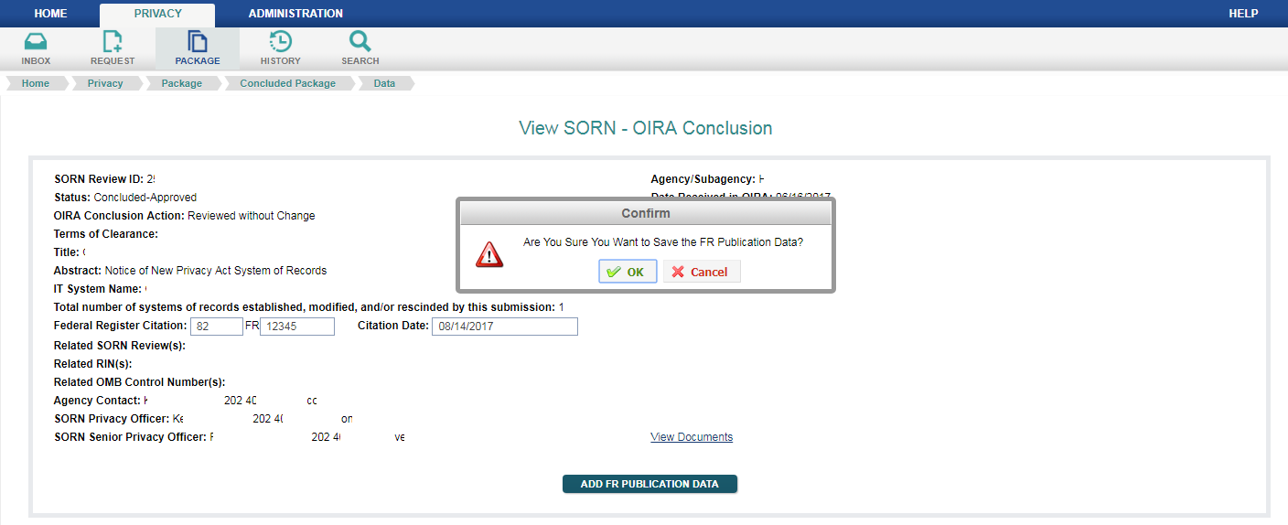

Figure 13.1: View SORN – OIRA Conclusion Screen (Not Published)

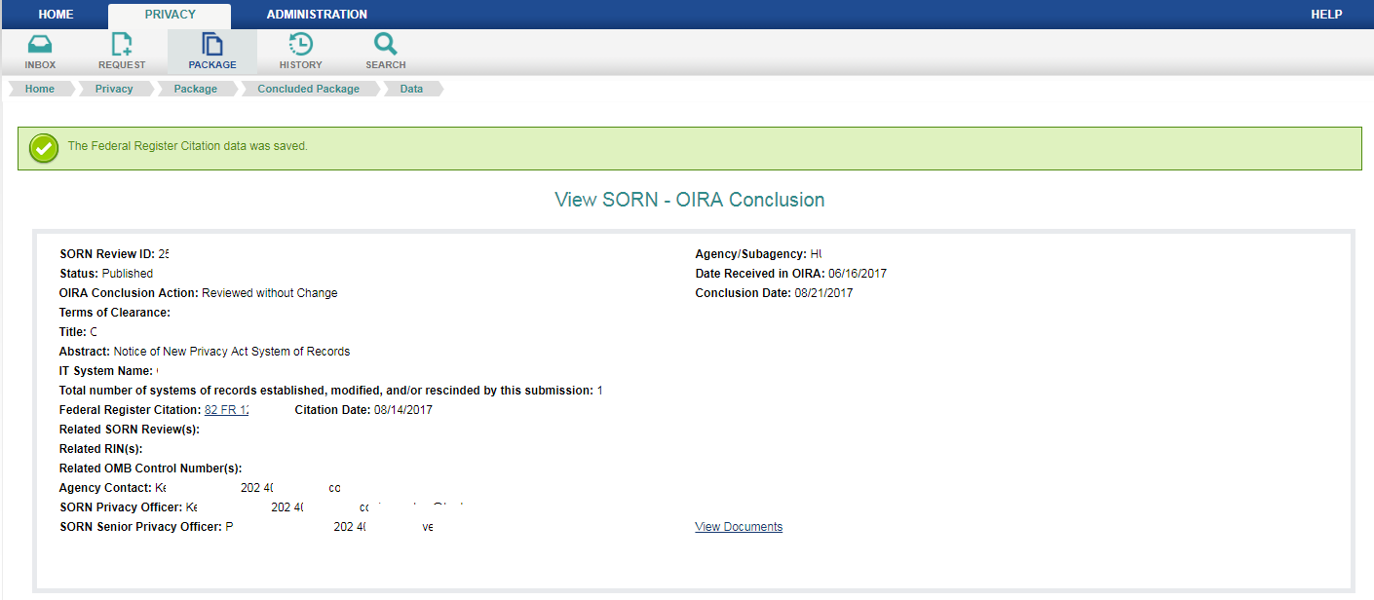

Figure 13.2: View SORN – OIRA Conclusion Screen (Published)

Appendix A: Required Documents

Content of the Report of a New or Modified System of Records. The report of a new or significantly modified system of records includes a transmittal letter, a narrative statement, a draft Federal Register notice, any Privacy Act exemption rules, and any supplementary documents.

- Transmittal Letter. The transmittal letter serves as a brief cover letter accompanying the report. The transmittal letter shall:
  - Be signed by the Senior Agency Official for Privacy.
  - Contain the name, email address, and telephone number of the individual who can best answer questions about the proposed system of records.
  - Contain the agency’s assurance that the proposed system of records fully complies with the Privacy Act and OMB policies.
  - Contain the agency’s assurance that the proposed system of records does not duplicate any existing agency or government-wide systems of records.
- Narrative Statement. The narrative statement provides a brief overview of the proposed system of records making reference to the other materials in the report without simply restating information provided in those materials. The narrative statement shall:
  - Describe the purpose(s) for which the agency is establishing or modifying the system of records and explain how the scope of the system is commensurate with the purpose(s) of the system.
  - Identify the specific authority (statute or executive order) under which the system of records will be maintained. The agency shall avoid citing authority that is overly general; rather, the agency shall cite the specific programmatic authority for collecting, maintaining, using, and disseminating the information.
  - An evaluation of the probable or potential effect of the proposal on the privacy of individuals whose information will be maintained in the system of records.70 If the agency has conducted one or more privacy impact assessment(s) with respect to information technology that will be used to collect, maintain, or disseminate the information in the system of records, the privacy impact assessment(s) will likely provide the information necessary to meet this requirement, and may be submitted in lieu of drafting a separate evaluation.
  - Explain how each new or modified routine use satisfies the compatibility requirement of the Privacy Act.
  - Identify any information collections approved by OMB or submitted to OMB for approval that will be used to collect information that will be maintained in the system of records, and provide the relevant names, OMB control numbers, and expiration dates. If the request for OMB approval of an information collection is pending, the agency may simply state the name of the collection and the date it was submitted to OMB for review.
- Federal Register Notice. The draft new or revised notice in the format prescribed by the Office of the Federal Register SORN templates, which are provided in the appendices to this Circular.
- Exemption Rule. Any new Privacy Act exemption rules or changes to published exemption rules in Federal Register format that the agency proposes to issue that will apply to records in the new or significantly modified system of records.
- Supplementary Documents. The supplementary documents include:
  - For significantly modified systems, the agency shall include a list of the substantive changes to the previously published version of the notice and/or a version of the previously published notice that has been marked up to show the changes that are being proposed.
  - The agency shall include any other supplementary documents requested by OMB.
Content of the Report of a New or Modified Matching Program. The report of an established, re-established, or significantly modified matching program includes a transmittal letter, a narrative statement, a draft Federal Register notice, at least 1 matching agreement, and any supplementary documents.

- Transmittal Letter. The transmittal letter serves as a brief cover letter accompanying the report. The transmittal letter shall:
  - Be signed by the Senior Agency Official for Privacy or the chairman of the Data Integrity Board.
  - Contain the name, email address, and telephone number of the individual who can best answer questions about the proposed matching program.
  - Contain the agency’s assurance that the proposed matching program was approved by the agency’s Data Integrity Board and fully complies with the Privacy Act and OMB policies.
- Narrative Statement. The narrative statement provides a brief overview of the proposed matching program making reference to the other materials in the report without simply restating information provided in those materials. The narrative statement shall:
  - Describe the purpose(s) for which the agency is establishing, re-establishing, or significantly modifying the matching program.
  - Identify the specific authority (statute or executive order) under which the agency is conducting the matching program. The agency shall avoid citing authority that is overly general; rather, the agency shall cite the specific programmatic authority for conducting the matching program.
  - Describe the administrative, technical, and physical safeguards in place to protect against unauthorized access to records used in the matching program.
  - Provide the agency’s specific evaluation of the potential impact on the privacy of individuals whose records will be used in the matching program.
  - Indicate whether a cost-benefit analysis was performed for the matching program, describe the results of the cost-benefit analysis, and explain the basis on which the agency is justifying the matching program.
- Federal Register Notice. The draft new or revised matching notice in the format prescribed by the Office of the Federal Register matching notice templates, which are provided in the appendices to this Circular.
- Matching Agreement. The full matching agreement(s) that was approved by the agency’s Data Integrity Board.
- Supplementary Documents. The supplementary documents include:
  - For significantly modified matching programs, the agency shall include a list of the substantive changes to the previously published version of the matching notice and/or a version of the previously published matching notice that has been marked up to show the changes that are being proposed.
  - The agency shall include any other supplementary documents requested by OMB.

Appendix B: SORN Agency Roles

There are five roles within ROCIS that are specifically associated with the agency portion of the SORN module:

SORN Preparer (SP) – This individual can create and update SORN and MA requests. To obtain a ROCIS account, they have to go through the agency’s SORN Administrative Contact (SAC) and sign a security agreement.

SORN Privacy Officer (SPO) – This individual can do everything that a SORN Preparer can, but can also submit a request to OIRA for review on behalf of the agency’s SORN Senior Privacy Officer (SSPO). To obtain a ROCIS account, the SPO must go through the agency’s SORN Administrative Contact and sign a security agreement. Additionally, the ROCIS technical team must receive approval from the agency SSPO, authorizing the new SPO to submit requests to OIRA. Each agency must have at least one of these.

SORN Publication Date Updater (SPU) – A person with this role is allowed to add a publication citation to a previously reviewed SORN or MA request. This role may be combined with any of the roles described above. Each agency must have at least one of these.

SORN Administrative Contact (SAC) – This person is the primary point of contact for an agency with regard to new accounts. If someone from an agency wants an account with access to the Privacy module, the request must be made through the SORN Administrative Contact. The SAC will inform the ROCIS technical team of whether the new user will be an SP or an SPO and, if applicable, the subagencies within the agency to which the user should have access. Each agency should have one of these (only 1 SAC per agency code).

This SAC role actually has no ROCIS privileges associated with it, so there are no requirements for a security agreement or training. However, in practice, almost all SACs are also SPOs, and all of the conditions for an SPO apply to them.

A change in an agency SAC is normally handled by the outgoing SAC, who notifies the ROCIS technical team of his replacement. If there is any question about who the SAC for an agency is, the ROCIS technical team will ask the SSPO to name the new SAC.

SORN Senior Privacy Officer (SSPO) – This person is ultimately responsible for verifying the accuracy and completeness of the information contained in each of the agency’s SORN and MA submissions. Every SORN and MA request submitted in ROCIS carries the SSPO’s identifying information.

The SSPO is responsible for delegating authority to agency SPOs, and, when necessary, naming the agency’s SAC. Each agency must have at least one of these (only 1 SSPO per agency code).

